alpha= 2

1 run......

Downloading: 100%

411/411 [00:00<00:00, 14.7kB/s]

Downloading: 100%

263M/263M [00:22<00:00, 12.9MB/s]

training 1 epoch...

835.0824301242828 seconds used......

1 training finished! average train loss: 0.7711534252870949

total clf loss: 294.4859590884298 total adv loss: 235.24911898747087

evaluating...

Confusion matrix, without normalization

[[ 37 220 37]

[ 27 3701 93]

[ 3 47 792]]

Normalized confusion matrix

[[0.12585034 0.74829932 0.12585034]

[0.00706621 0.96859461 0.02433918]

[0.00356295 0.05581948 0.94061758]]

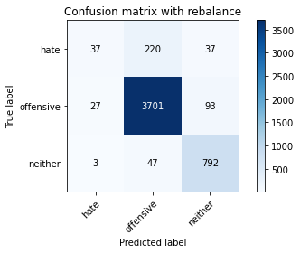

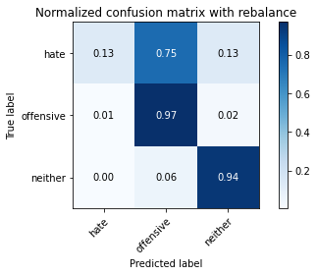

precision recall f1-score support

hate 0.55 0.13 0.20 294

offensive 0.93 0.97 0.95 3821

neither 0.86 0.94 0.90 842

accuracy 0.91 4957

macro avg 0.78 0.68 0.68 4957

weighted avg 0.90 0.91 0.90 4957

average eval_loss: 0.24112484372791745, accuracy: 0.9138591890256204

training 2 epoch...

834.3830845355988 seconds used......

2 training finished! average train loss: 0.5836339651291529

total clf loss: 212.63202552963048 total adv loss: 183.16643436532468

evaluating...

Confusion matrix, without normalization

[[ 82 200 12]

[ 67 3690 64]

[ 16 99 727]]

Normalized confusion matrix

[[0.27891156 0.68027211 0.04081633]

[0.01753468 0.96571578 0.01674954]

[0.01900238 0.1175772 0.86342043]]

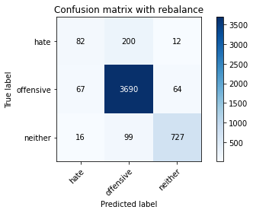

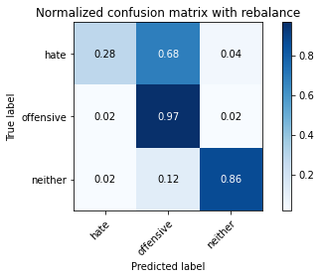

precision recall f1-score support

hate 0.50 0.28 0.36 294

offensive 0.93 0.97 0.94 3821

neither 0.91 0.86 0.88 842

accuracy 0.91 4957

macro avg 0.78 0.70 0.73 4957

weighted avg 0.90 0.91 0.90 4957

average eval_loss: 0.24882146812254383, accuracy: 0.9076054064958644

training 3 epoch...

834.3302574157715 seconds used......

3 training finished! average train loss: 0.4490607033292162

total clf loss: 162.62118059489876 total adv loss: 141.42351845017402

evaluating...

Confusion matrix, without normalization

[[ 135 143 16]

[ 123 3629 69]

[ 15 76 751]]

Normalized confusion matrix

[[0.45918367 0.48639456 0.05442177]

[0.03219053 0.94975137 0.0180581 ]

[0.01781473 0.09026128 0.89192399]]

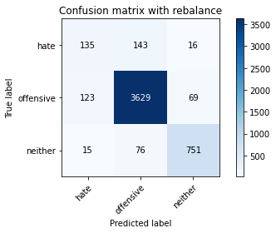

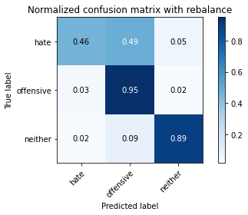

precision recall f1-score support

hate 0.49 0.46 0.48 294

offensive 0.94 0.95 0.95 3821

neither 0.90 0.89 0.90 842

accuracy 0.91 4957

macro avg 0.78 0.77 0.77 4957

weighted avg 0.91 0.91 0.91 4957

average eval_loss: 0.2596184815911035, accuracy: 0.9108331652208997

training 4 epoch...

842.0122909545898 seconds used......

4 training finished! average train loss: 0.3035268409113351

total clf loss: 109.63617082603741 total adv loss: 95.73122737352969

evaluating...

Confusion matrix, without normalization

[[ 112 165 17]

[ 94 3652 75]

[ 23 77 742]]

Normalized confusion matrix

[[0.38095238 0.56122449 0.05782313]

[0.02460089 0.95577074 0.01962837]

[0.02731591 0.09144893 0.88123515]]

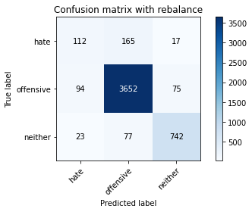

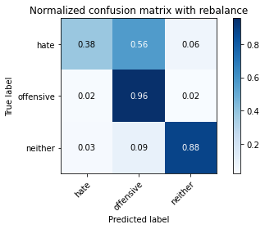

precision recall f1-score support

hate 0.49 0.38 0.43 294

offensive 0.94 0.96 0.95 3821

neither 0.89 0.88 0.89 842

accuracy 0.91 4957

macro avg 0.77 0.74 0.75 4957

weighted avg 0.90 0.91 0.91 4957

average eval_loss: 0.3180152919423211, accuracy: 0.9090175509380674

training 5 epoch...

834.6131920814514 seconds used......

5 training finished! average train loss: 0.1857770384959299

total clf loss: 68.12310157087632 total adv loss: 58.083860286809795

evaluating...

Confusion matrix, without normalization

[[ 77 201 16]

[ 70 3696 55]

[ 11 115 716]]

Normalized confusion matrix

[[0.26190476 0.68367347 0.05442177]

[0.01831981 0.96728605 0.01439414]

[0.01306413 0.13657957 0.85035629]]

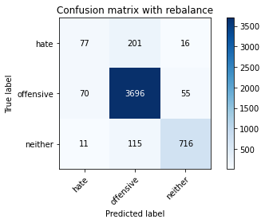

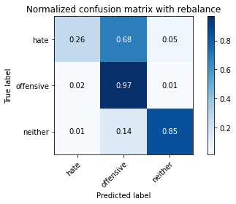

precision recall f1-score support

hate 0.49 0.26 0.34 294

offensive 0.92 0.97 0.94 3821

neither 0.91 0.85 0.88 842

accuracy 0.91 4957

macro avg 0.77 0.69 0.72 4957

weighted avg 0.89 0.91 0.90 4957

average eval_loss: 0.3911963025138022, accuracy: 0.9055880572927174

training 6 epoch...

834.5630152225494 seconds used......

6 training finished! average train loss: 0.11052640354839768

total clf loss: 41.226397783873836 total adv loss: 34.207897311952365

evaluating...

Confusion matrix, without normalization

[[ 96 181 17]

[ 82 3668 71]

[ 20 77 745]]

Normalized confusion matrix

[[0.32653061 0.61564626 0.05782313]

[0.02146035 0.95995813 0.01858152]

[0.02375297 0.09144893 0.8847981 ]]

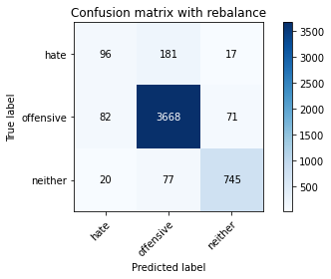

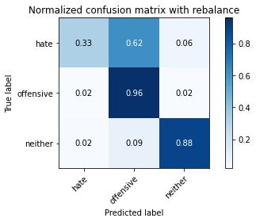

precision recall f1-score support

hate 0.48 0.33 0.39 294

offensive 0.93 0.96 0.95 3821

neither 0.89 0.88 0.89 842

accuracy 0.91 4957

macro avg 0.77 0.72 0.74 4957

weighted avg 0.90 0.91 0.90 4957

average eval_loss: 0.4554634904199643, accuracy: 0.9096227556990115

training 7 epoch...

834.7828433513641 seconds used......

7 training finished! average train loss: 0.07873310181085183

total clf loss: 28.834668962386786 total adv loss: 24.634283873941058

evaluating...

Confusion matrix, without normalization

[[ 103 177 14]

[ 82 3667 72]

[ 36 67 739]]

Normalized confusion matrix

[[0.35034014 0.60204082 0.04761905]

[0.02146035 0.95969641 0.01884323]

[0.04275534 0.07957245 0.87767221]]

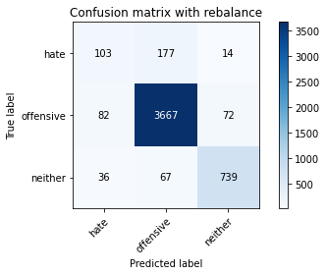

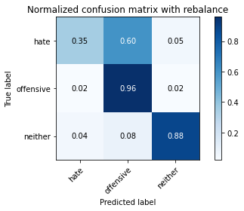

precision recall f1-score support

hate 0.47 0.35 0.40 294

offensive 0.94 0.96 0.95 3821

neither 0.90 0.88 0.89 842

accuracy 0.91 4957

macro avg 0.77 0.73 0.75 4957

weighted avg 0.90 0.91 0.91 4957

average eval_loss: 0.47816264845894163, accuracy: 0.9096227556990115

training 8 epoch...

834.95969414711 seconds used......

8 training finished! average train loss: 0.055706085244574134

total clf loss: 21.333828500501113 total adv loss: 16.963304079160906

evaluating...

Confusion matrix, without normalization

[[ 73 209 12]

[ 69 3703 49]

[ 22 103 717]]

Normalized confusion matrix

[[0.24829932 0.71088435 0.04081633]

[0.0180581 0.96911803 0.01282387]

[0.02612827 0.12232779 0.85154394]]

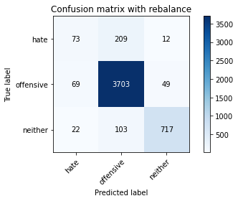

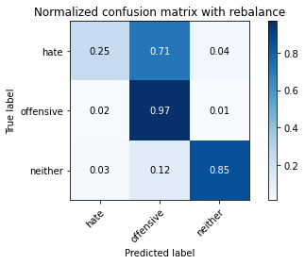

precision recall f1-score support

hate 0.45 0.25 0.32 294

offensive 0.92 0.97 0.95 3821

neither 0.92 0.85 0.89 842

accuracy 0.91 4957

macro avg 0.76 0.69 0.72 4957

weighted avg 0.89 0.91 0.90 4957

average eval_loss: 0.5620625734512238, accuracy: 0.9063949969739762

training 9 epoch...

835.0836081504822 seconds used......

9 training finished! average train loss: 0.045851869671251266

total clf loss: 16.966120563822187 total adv loss: 14.259467000935189

evaluating...

Confusion matrix, without normalization

[[ 71 208 15]

[ 64 3692 65]

[ 12 92 738]]

Normalized confusion matrix

[[0.2414966 0.70748299 0.05102041]

[0.01674954 0.9662392 0.01701125]

[0.01425178 0.10926366 0.87648456]]

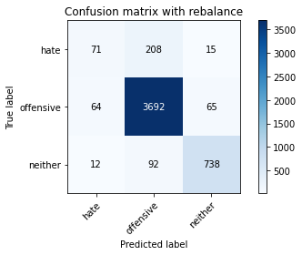

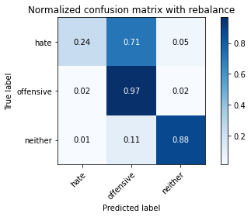

precision recall f1-score support

hate 0.48 0.24 0.32 294

offensive 0.92 0.97 0.95 3821

neither 0.90 0.88 0.89 842

accuracy 0.91 4957

macro avg 0.77 0.69 0.72 4957

weighted avg 0.89 0.91 0.90 4957

average eval_loss: 0.5429789065742918, accuracy: 0.9080088763364939

training 10 epoch...

835.6074252128601 seconds used......

10 training finished! average train loss: 0.04715210053756979

total clf loss: 16.319921838603477 total adv loss: 15.227480980985462

evaluating...

Confusion matrix, without normalization

[[ 110 170 14]

[ 114 3657 50]

[ 37 105 700]]

Normalized confusion matrix

[[0.37414966 0.57823129 0.04761905]

[0.02983512 0.9570793 0.01308558]

[0.04394299 0.12470309 0.83135392]]

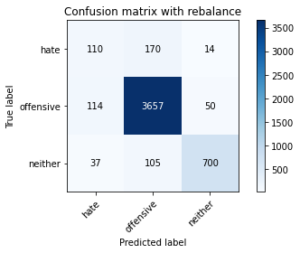

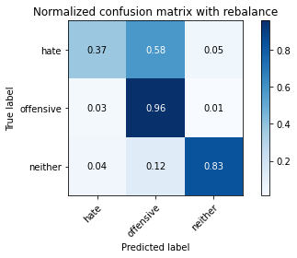

precision recall f1-score support

hate 0.42 0.37 0.40 294

offensive 0.93 0.96 0.94 3821

neither 0.92 0.83 0.87 842

accuracy 0.90 4957

macro avg 0.76 0.72 0.74 4957

weighted avg 0.90 0.90 0.90 4957

average eval_loss: 0.542109008821362, accuracy: 0.9011498890457939

2 run......

training 1 epoch...

836.1962625980377 seconds used......

1 training finished! average train loss: 0.7561189518009703

total clf loss: 287.40670699998736 total adv loss: 231.33164627617225

evaluating...

Confusion matrix, without normalization

[[ 53 218 23]

[ 38 3723 60]

[ 2 116 724]]

Normalized confusion matrix

[[0.18027211 0.7414966 0.07823129]

[0.00994504 0.97435226 0.0157027 ]

[0.0023753 0.13776722 0.85985748]]

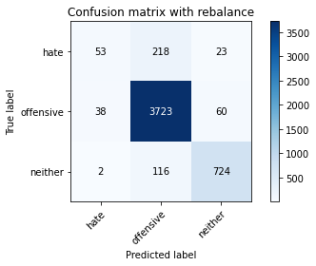

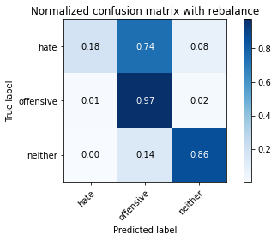

precision recall f1-score support

hate 0.57 0.18 0.27 294

offensive 0.92 0.97 0.95 3821

neither 0.90 0.86 0.88 842

accuracy 0.91 4957

macro avg 0.79 0.67 0.70 4957

weighted avg 0.89 0.91 0.89 4957

average eval_loss: 0.24715083170562022, accuracy: 0.9078071414161791

training 2 epoch...

836.1080236434937 seconds used......

2 training finished! average train loss: 0.576509451088045

total clf loss: 209.69750519562513 total adv loss: 181.09993490064517

evaluating...

Confusion matrix, without normalization

[[ 87 175 32]

[ 65 3666 90]

[ 0 57 785]]

Normalized confusion matrix

[[0.29591837 0.5952381 0.10884354]

[0.01701125 0.9594347 0.02355404]

[0. 0.06769596 0.93230404]]

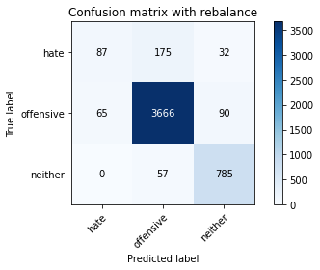

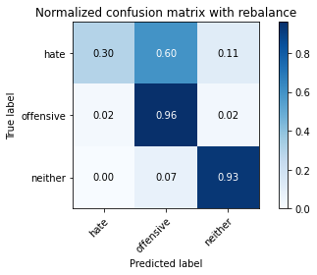

precision recall f1-score support

hate 0.57 0.30 0.39 294

offensive 0.94 0.96 0.95 3821

neither 0.87 0.93 0.90 842

accuracy 0.92 4957

macro avg 0.79 0.73 0.75 4957

weighted avg 0.91 0.92 0.91 4957

average eval_loss: 0.24194672943333223, accuracy: 0.915473068388138

training 3 epoch...

836.320433139801 seconds used......

3 training finished! average train loss: 0.4335254246909772

total clf loss: 156.40775278536603 total adv loss: 136.82473439001478

evaluating...

Confusion matrix, without normalization

[[ 115 160 19]

[ 83 3674 64]

[ 15 80 747]]

Normalized confusion matrix

[[0.39115646 0.54421769 0.06462585]

[0.02172206 0.9615284 0.01674954]

[0.01781473 0.09501188 0.8871734 ]]

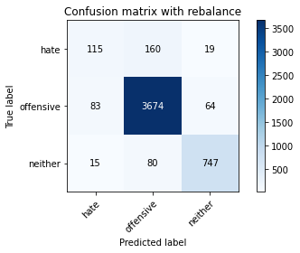

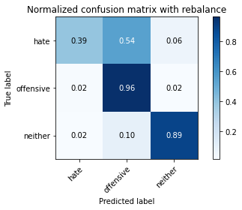

precision recall f1-score support

hate 0.54 0.39 0.45 294

offensive 0.94 0.96 0.95 3821

neither 0.90 0.89 0.89 842

accuracy 0.92 4957

macro avg 0.79 0.75 0.77 4957

weighted avg 0.91 0.92 0.91 4957

average eval_loss: 0.25394401596032923, accuracy: 0.9150695985475086

training 4 epoch...

837.2396395206451 seconds used......

4 training finished! average train loss: 0.2975937631495218

total clf loss: 107.41388444066979 total adv loss: 93.8995642940863

evaluating...

Confusion matrix, without normalization

[[ 81 194 19]

[ 51 3707 63]

[ 20 88 734]]

Normalized confusion matrix

[[0.2755102 0.65986395 0.06462585]

[0.01334729 0.97016488 0.01648783]

[0.02375297 0.10451306 0.87173397]]

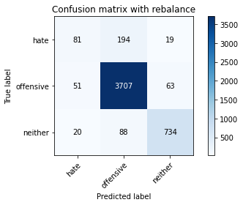

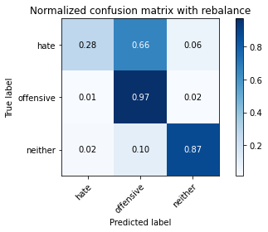

precision recall f1-score support

hate 0.53 0.28 0.36 294

offensive 0.93 0.97 0.95 3821

neither 0.90 0.87 0.89 842

accuracy 0.91 4957

macro avg 0.79 0.71 0.73 4957

weighted avg 0.90 0.91 0.90 4957

average eval_loss: 0.3221210701292054, accuracy: 0.9122453096631027

training 5 epoch...

another try

1 run......

Downloading: 100%

411/411 [00:00<00:00, 14.3kB/s]

Downloading: 100%

263M/263M [00:12<00:00, 22.6MB/s]

training 1 epoch...

836.3269603252411 seconds used......

1 training finished! average train loss: 0.7588758930533884

total clf loss: 289.4071180522442 total adv loss: 231.69888398237526

evaluating...

Confusion matrix, without normalization

[[ 46 227 21]

[ 36 3713 72]

[ 2 111 729]]

Normalized confusion matrix

[[0.15646259 0.77210884 0.07142857]

[0.00942162 0.97173515 0.01884323]

[0.0023753 0.13182898 0.86579572]]

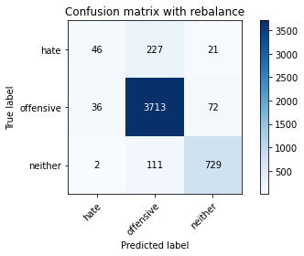

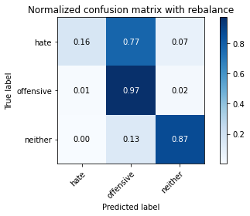

precision recall f1-score support

hate 0.55 0.16 0.24 294

offensive 0.92 0.97 0.94 3821

neither 0.89 0.87 0.88 842

accuracy 0.91 4957

macro avg 0.78 0.66 0.69 4957

weighted avg 0.89 0.91 0.89 4957

average eval_loss: 0.2538435467473802, accuracy: 0.9053863223724027

training 2 epoch...

836.0939927101135 seconds used......

2 training finished! average train loss: 0.5748705083932427

total clf loss: 211.06758762616664 total adv loss: 179.6019787164405

evaluating...

Confusion matrix, without normalization

[[ 138 136 20]

[ 124 3628 69]

[ 10 73 759]]

Normalized confusion matrix

[[0.46938776 0.46258503 0.06802721]

[0.03245224 0.94948966 0.0180581 ]

[0.01187648 0.08669834 0.90142518]]

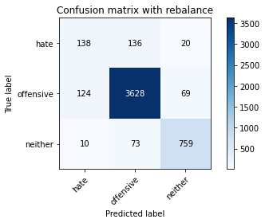

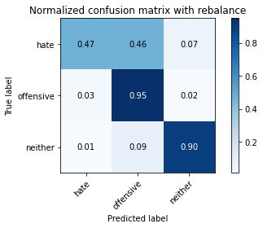

precision recall f1-score support

hate 0.51 0.47 0.49 294

offensive 0.95 0.95 0.95 3821

neither 0.90 0.90 0.90 842

accuracy 0.91 4957

macro avg 0.78 0.77 0.78 4957

weighted avg 0.91 0.91 0.91 4957

average eval_loss: 0.247952522950307, accuracy: 0.9128505144240469

training 3 epoch...

836.0336785316467 seconds used......

3 training finished! average train loss: 0.448236086646155

total clf loss: 163.03214356233366 total adv loss: 140.8090273179114

evaluating...

Confusion matrix, without normalization

[[ 110 165 19]

[ 104 3634 83]

[ 12 50 780]]

Normalized confusion matrix

[[0.37414966 0.56122449 0.06462585]

[0.02721801 0.95105993 0.02172206]

[0.01425178 0.05938242 0.9263658 ]]

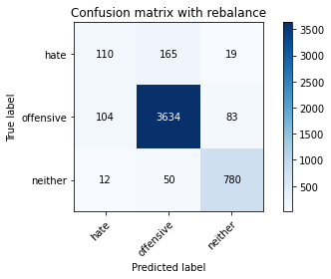

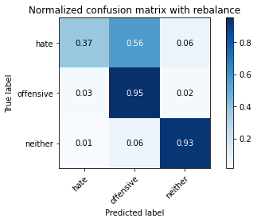

precision recall f1-score support

hate 0.49 0.37 0.42 294

offensive 0.94 0.95 0.95 3821

neither 0.88 0.93 0.90 842

accuracy 0.91 4957

macro avg 0.77 0.75 0.76 4957

weighted avg 0.91 0.91 0.91 4957

average eval_loss: 0.26422851255929636, accuracy: 0.9126487795037321

training 4 epoch...

835.4279315471649 seconds used......

4 training finished! average train loss: 0.3153523004617572

total clf loss: 113.43938782531768 total adv loss: 99.69504711221089

evaluating...

Confusion matrix, without normalization

[[ 98 180 16]

[ 104 3665 52]

[ 25 102 715]]

Normalized confusion matrix

[[0.33333333 0.6122449 0.05442177]

[0.02721801 0.95917299 0.013609 ]

[0.02969121 0.12114014 0.84916865]]

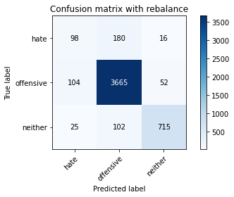

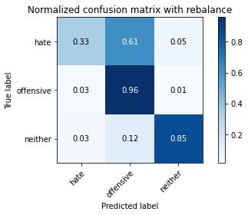

precision recall f1-score support

hate 0.43 0.33 0.38 294

offensive 0.93 0.96 0.94 3821

neither 0.91 0.85 0.88 842

accuracy 0.90 4957

macro avg 0.76 0.71 0.73 4957

weighted avg 0.90 0.90 0.90 4957

average eval_loss: 0.3214792538370426, accuracy: 0.9033689731692556

training 5 epoch...

835.4482624530792 seconds used......

5 training finished! average train loss: 0.18395499696634943

total clf loss: 66.70796164657804 total adv loss: 57.887697610211035

evaluating...

Confusion matrix, without normalization

[[ 137 140 17]

[ 222 3519 80]

[ 25 59 758]]

Normalized confusion matrix

[[0.46598639 0.47619048 0.05782313]

[0.05809997 0.9209631 0.02093693]

[0.02969121 0.07007126 0.90023753]]

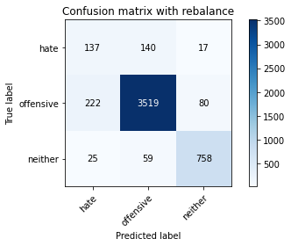

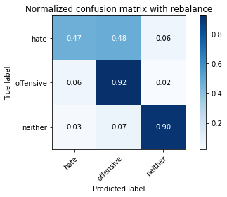

precision recall f1-score support

hate 0.36 0.47 0.40 294

offensive 0.95 0.92 0.93 3821

neither 0.89 0.90 0.89 842

accuracy 0.89 4957

macro avg 0.73 0.76 0.74 4957

weighted avg 0.90 0.89 0.90 4957

average eval_loss: 0.40457401440958607, accuracy: 0.8904579382691143

training 6 epoch...

834.8874564170837 seconds used......

6 training finished! average train loss: 0.10409918662530653

total clf loss: 39.1288398913166 total adv loss: 32.068776459815126

evaluating...

Confusion matrix, without normalization

[[ 107 173 14]

[ 121 3628 72]

[ 27 62 753]]

Normalized confusion matrix

[[0.36394558 0.58843537 0.04761905]

[0.0316671 0.94948966 0.01884323]

[0.03206651 0.0736342 0.89429929]]

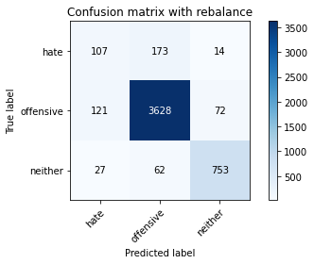

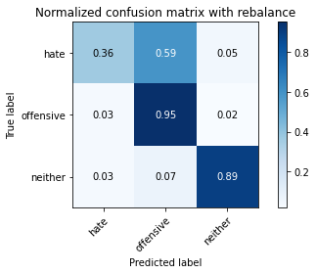

precision recall f1-score support

hate 0.42 0.36 0.39 294

offensive 0.94 0.95 0.94 3821

neither 0.90 0.89 0.90 842

accuracy 0.91 4957

macro avg 0.75 0.74 0.74 4957

weighted avg 0.90 0.91 0.90 4957

average eval_loss: 0.44441754255169674, accuracy: 0.9053863223724027

training 7 epoch...

834.7368426322937 seconds used......

7 training finished! average train loss: 0.0755485090684077

total clf loss: 28.31643155265192 total adv loss: 23.313844694263935

evaluating...

Confusion matrix, without normalization

[[ 92 183 19]

[ 85 3666 70]

[ 24 74 744]]

Normalized confusion matrix

[[0.31292517 0.62244898 0.06462585]

[0.02224549 0.9594347 0.01831981]

[0.02850356 0.08788599 0.88361045]]

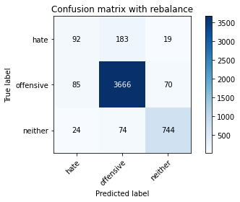

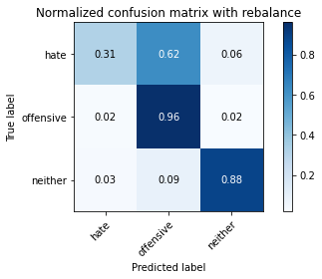

precision recall f1-score support

hate 0.46 0.31 0.37 294

offensive 0.93 0.96 0.95 3821

neither 0.89 0.88 0.89 842

accuracy 0.91 4957

macro avg 0.76 0.72 0.74 4957

weighted avg 0.90 0.91 0.90 4957

average eval_loss: 0.5281066765449894, accuracy: 0.9082106112568086

training 8 epoch...

834.9877052307129 seconds used......

8 training finished! average train loss: 0.058467239665578895

total clf loss: 21.879351363011665 total adv loss: 18.060075219903183

evaluating...

Confusion matrix, without normalization

[[ 124 160 10]

[ 193 3594 34]

[ 56 132 654]]

Normalized confusion matrix

[[0.42176871 0.54421769 0.03401361]

[0.05051034 0.94059147 0.00889819]

[0.06650831 0.1567696 0.77672209]]

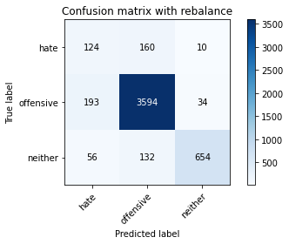

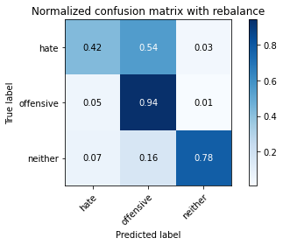

precision recall f1-score support

hate 0.33 0.42 0.37 294

offensive 0.92 0.94 0.93 3821

neither 0.94 0.78 0.85 842

accuracy 0.88 4957

macro avg 0.73 0.71 0.72 4957

weighted avg 0.89 0.88 0.89 4957

average eval_loss: 0.5444209978058127, accuracy: 0.8819850716158967

training 9 epoch...

835.0172860622406 seconds used......

9 training finished! average train loss: 0.05490672622830707

total clf loss: 20.146721815726778 total adv loss: 17.16037532842472

evaluating...

Confusion matrix, without normalization

[[ 110 167 17]

[ 122 3626 73]

[ 23 73 746]]

Normalized confusion matrix

[[0.37414966 0.56802721 0.05782313]

[0.03192881 0.94896624 0.01910495]

[0.02731591 0.08669834 0.88598575]]

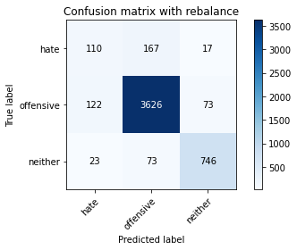

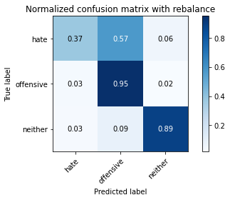

precision recall f1-score support

hate 0.43 0.37 0.40 294

offensive 0.94 0.95 0.94 3821

neither 0.89 0.89 0.89 842

accuracy 0.90 4957

macro avg 0.75 0.74 0.74 4957

weighted avg 0.90 0.90 0.90 4957

average eval_loss: 0.5437614979881976, accuracy: 0.9041759128505145

training 10 epoch...

835.1041302680969 seconds used......

10 training finished! average train loss: 0.041816780309213826

total clf loss: 14.85584271647349 total adv loss: 13.313201748991958

evaluating...

Confusion matrix, without normalization

[[ 80 194 20]

[ 90 3657 74]

[ 10 80 752]]

Normalized confusion matrix

[[0.27210884 0.65986395 0.06802721]

[0.02355404 0.9570793 0.01936666]

[0.01187648 0.09501188 0.89311164]]

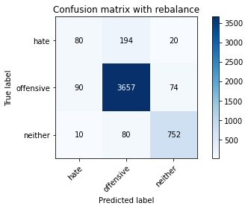

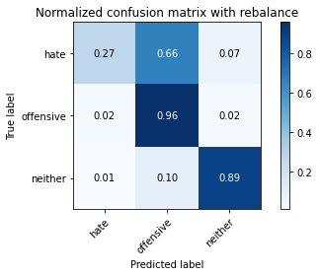

precision recall f1-score support

hate 0.44 0.27 0.34 294

offensive 0.93 0.96 0.94 3821

neither 0.89 0.89 0.89 842

accuracy 0.91 4957

macro avg 0.75 0.71 0.72 4957

weighted avg 0.89 0.91 0.90 4957

average eval_loss: 0.5570156100563743, accuracy: 0.9055880572927174

2 run......

training 1 epoch...

835.1397800445557 seconds used......

1 training finished! average train loss: 0.764614327803194

total clf loss: 288.2706684395671 total adv loss: 235.11337239295244

evaluating...

Confusion matrix, without normalization

[[ 24 225 45]

[ 21 3708 92]

[ 1 64 777]]

Normalized confusion matrix

[[0.08163265 0.76530612 0.15306122]

[0.00549594 0.97042659 0.02407747]

[0.00118765 0.0760095 0.92280285]]

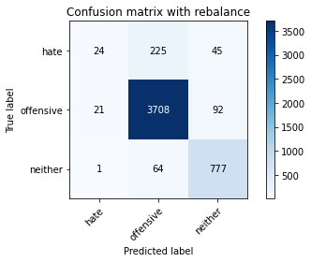

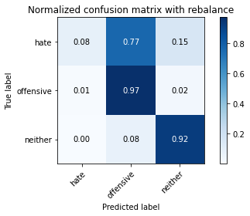

precision recall f1-score support

hate 0.52 0.08 0.14 294

offensive 0.93 0.97 0.95 3821

neither 0.85 0.92 0.88 842

accuracy 0.91 4957

macro avg 0.77 0.66 0.66 4957

weighted avg 0.89 0.91 0.89 4957

average eval_loss: 0.25456391352664437, accuracy: 0.9096227556990115

training 2 epoch...

835.1409170627594 seconds used......

2 training finished! average train loss: 0.5740513614183592

total clf loss: 210.3171109361574 total adv loss: 179.57091950252652

evaluating...

Confusion matrix, without normalization

[[ 125 138 31]

[ 108 3614 99]

[ 5 38 799]]

Normalized confusion matrix

[[0.42517007 0.46938776 0.10544218]

[0.02826485 0.9458257 0.02590945]

[0.00593824 0.04513064 0.94893112]]

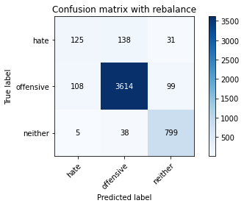

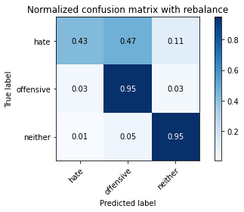

precision recall f1-score support

hate 0.53 0.43 0.47 294

offensive 0.95 0.95 0.95 3821

neither 0.86 0.95 0.90 842

accuracy 0.92 4957

macro avg 0.78 0.77 0.77 4957

weighted avg 0.91 0.92 0.91 4957

average eval_loss: 0.25180849070931155, accuracy: 0.915473068388138

training 3 epoch...

835.7811372280121 seconds used......

3 training finished! average train loss: 0.44183142506611356

total clf loss: 160.3376163225621 total adv loss: 138.9795785122551

evaluating...

Confusion matrix, without normalization

[[ 135 142 17]

[ 115 3627 79]

[ 10 69 763]]

Normalized confusion matrix

[[0.45918367 0.4829932 0.05782313]

[0.03009683 0.94922795 0.02067522]

[0.01187648 0.08194774 0.90617577]]

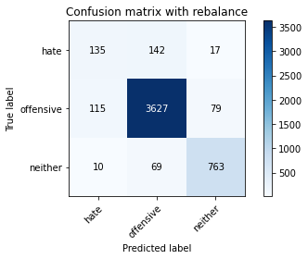

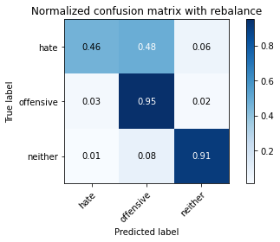

precision recall f1-score support

hate 0.52 0.46 0.49 294

offensive 0.95 0.95 0.95 3821

neither 0.89 0.91 0.90 842

accuracy 0.91 4957

macro avg 0.78 0.77 0.78 4957

weighted avg 0.91 0.91 0.91 4957

average eval_loss: 0.2693686815506343, accuracy: 0.9128505144240469

training 4 epoch...

836.0299270153046 seconds used......

4 training finished! average train loss: 0.3077255017617004

total clf loss: 111.98328642197885 total adv loss: 96.64020594605245

evaluating...

Confusion matrix, without normalization

[[ 85 195 14]

[ 77 3696 48]

[ 24 118 700]]

Normalized confusion matrix

[[0.28911565 0.66326531 0.04761905]

[0.02015179 0.96728605 0.01256216]

[0.02850356 0.14014252 0.83135392]]

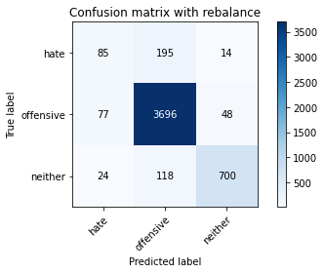

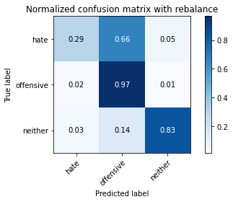

precision recall f1-score support

hate 0.46 0.29 0.35 294

offensive 0.92 0.97 0.94 3821

neither 0.92 0.83 0.87 842

accuracy 0.90 4957

macro avg 0.77 0.70 0.72 4957

weighted avg 0.89 0.90 0.90 4957

average eval_loss: 0.33248311438036315, accuracy: 0.9039741779301997

training 5 epoch...

835.6160373687744 seconds used......

5 training finished! average train loss: 0.18833271038062277

total clf loss: 69.10809158504708 total adv loss: 58.858978587566526

evaluating...

Confusion matrix, without normalization

[[ 113 154 27]

[ 114 3620 87]

[ 22 52 768]]

Normalized confusion matrix

[[0.38435374 0.52380952 0.09183673]

[0.02983512 0.94739597 0.02276891]

[0.02612827 0.06175772 0.91211401]]

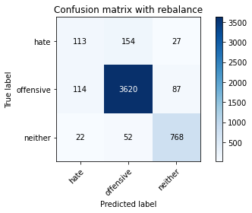

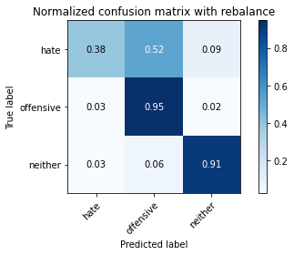

precision recall f1-score support

hate 0.45 0.38 0.42 294

offensive 0.95 0.95 0.95 3821

neither 0.87 0.91 0.89 842

accuracy 0.91 4957

macro avg 0.76 0.75 0.75 4957

weighted avg 0.90 0.91 0.91 4957

average eval_loss: 0.36983194404151176, accuracy: 0.9080088763364939

training 6 epoch...